Gender Detection Model

By Namya Sheth

Let’s first start with the overview of the code.

1. Importing the necessary libraries.
2. The provided dataset was very large to import the the dataset directly into google collab.
3. The dataset contained subfolders of Train, Test and Validation. The Train itself contained around 16k images. So, I first took 2000 images from Train, 400 from Test and 2000 from Validation and stored them into a new reduced folder.
4. From the reduced folder, since in the trial run the training time was still taking long, I took only the train data from the reduced folder labelled it and reduced the dimension by 2 of the images(to reduce the computations and thus decreasing the training time)
5. Then I created a model using various layers so that it train better.
6. Then I plot the graph of Accuracy and Loss versus epochs and showed the confusion matrix.
7. Then I implemented the webcam feature.

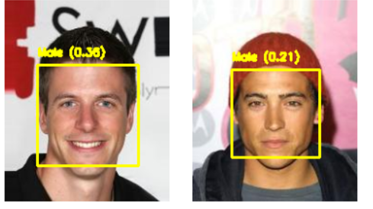

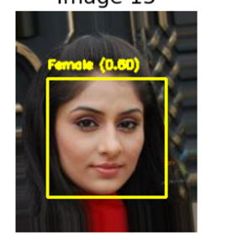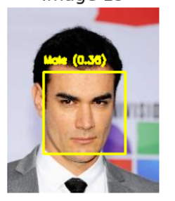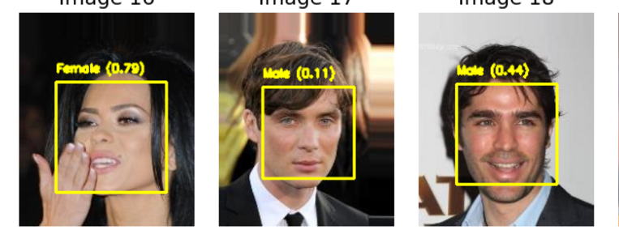

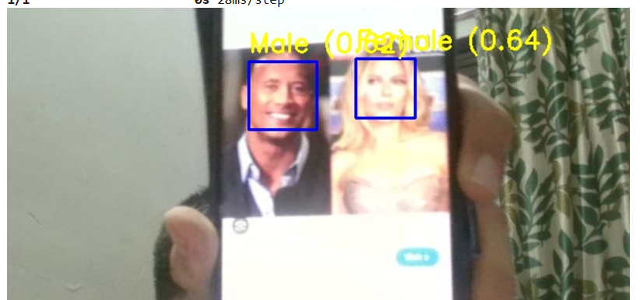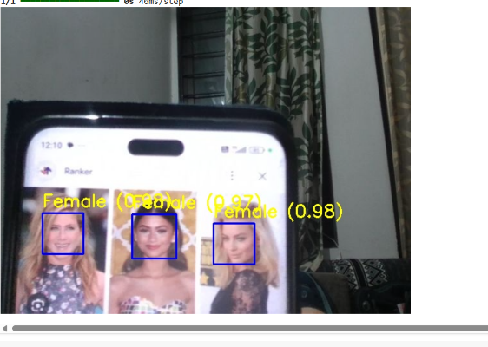This are some output images.

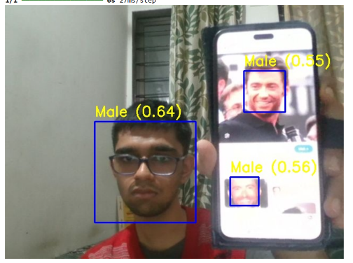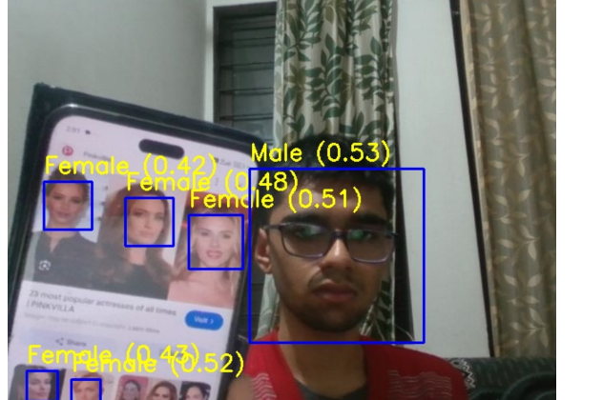

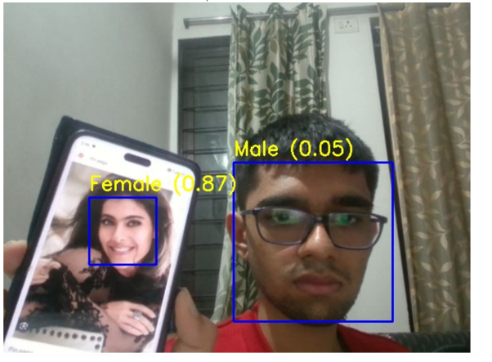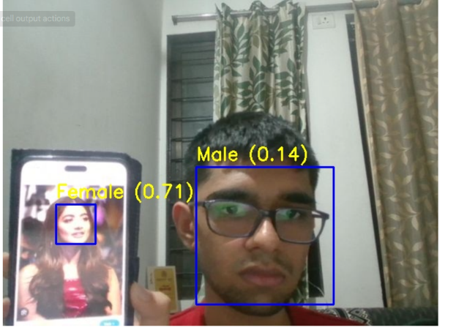

This are the outputs from the live detection camera.